Practical Activity Week6- Wireshark

Sally Mukami Kagai

[Sally.mukami@womentechsters.org](mailto:Sally.mukami@womentechsters.org)

1. What version of HTTP is the server running?

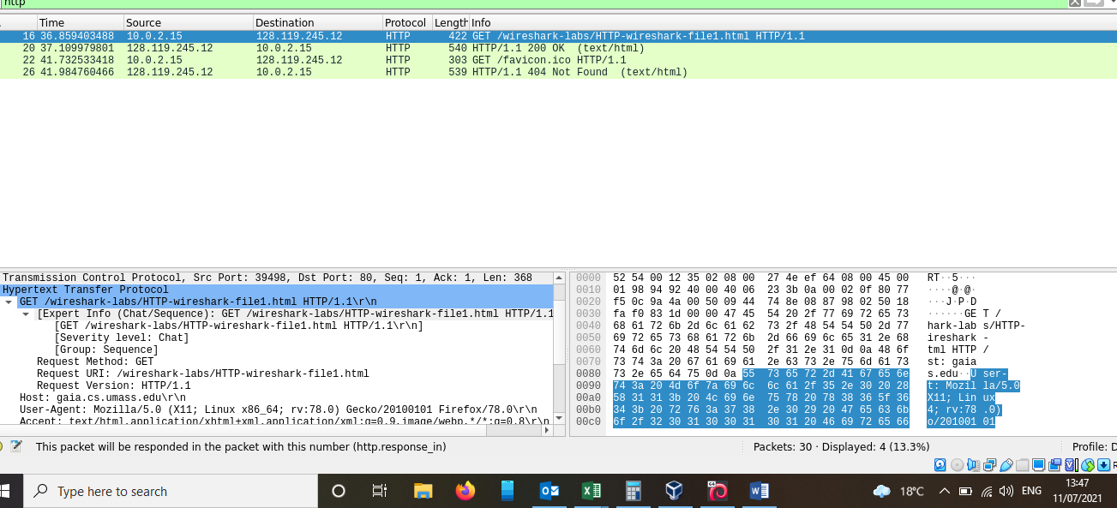

*My browser is running http version 1.1

*The server is also running version 1.1

**2. What language does the server accept?**

*The server indicates that it will accept English-US

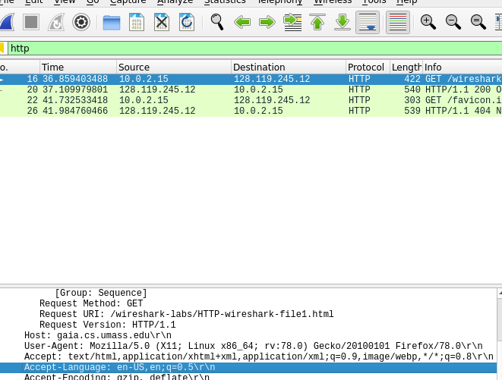

1. **What is the IP address of your computer, or gaia.cs.umass.edu server?**

**\***IP address of my computer is 10.0.2.15

**\***IP address of the server is 128.119.24.12



1. **What is the status code returned from the server to your browser?**

*the status code returned was 200 OK

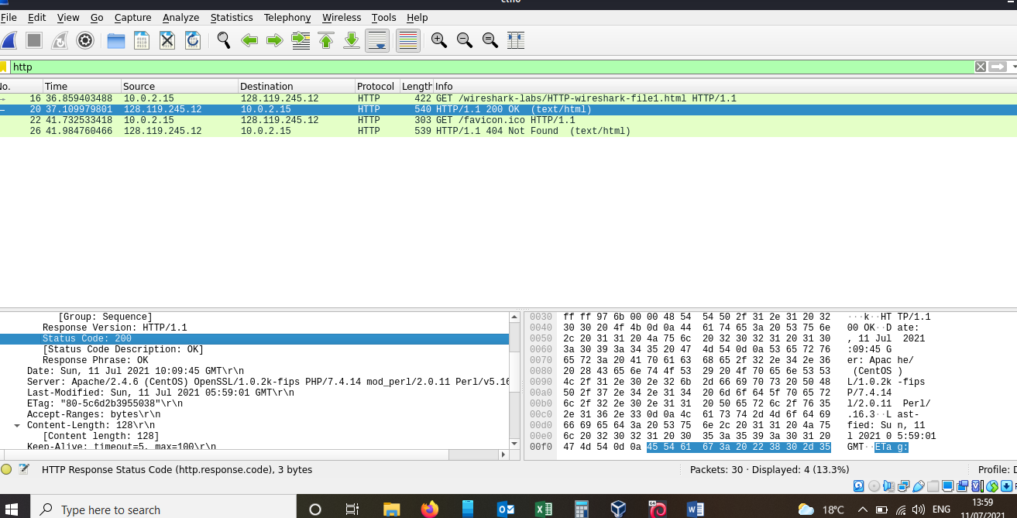

1. **When was the HTML file that you are retrieving last modified at the server?**

**\***The file was last modified on Sunday, 11 July 2021 05:59:01 GMT

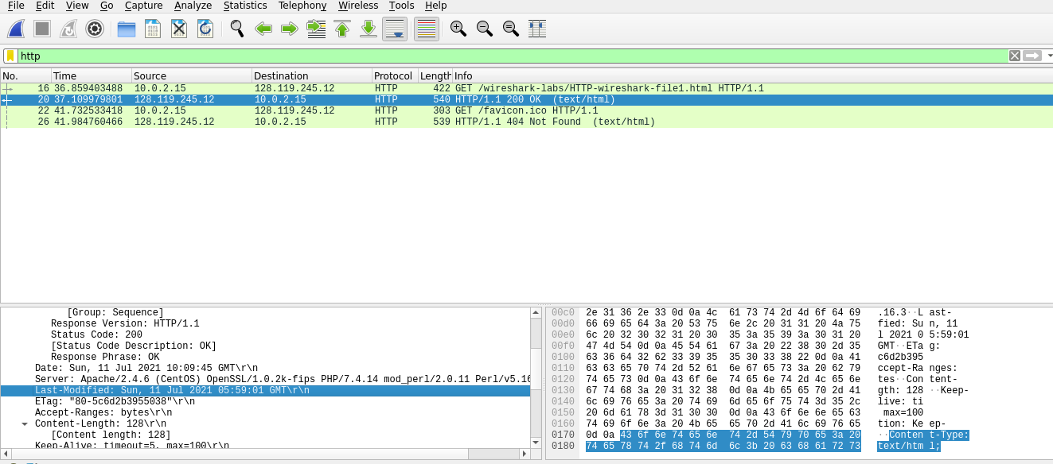

1. **How many bytes of content are being returned to your browser?**

*128 bytes of content being returned

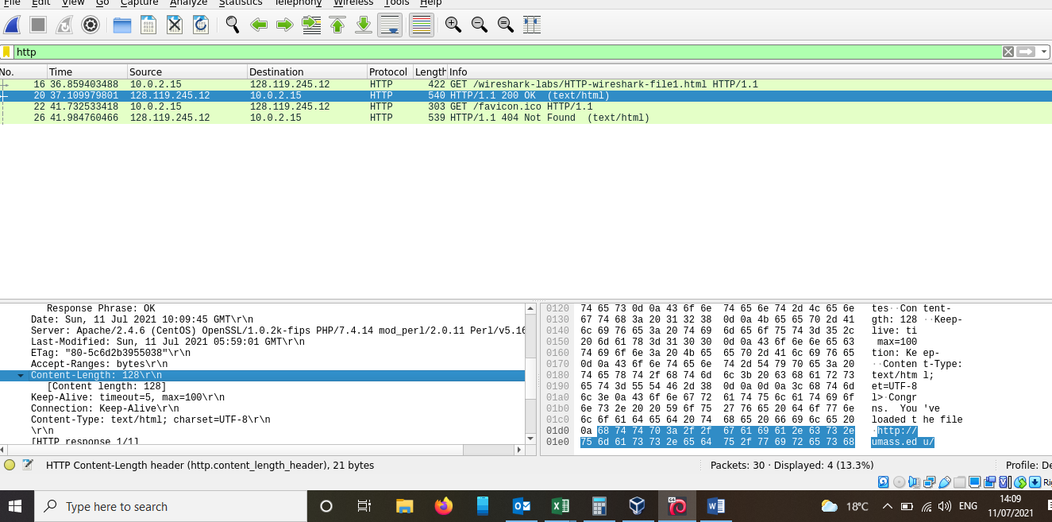

1. **By inspecting the raw data in the packet, do you see any headers within the data that are not displayed.**

*No I do not see any headings different between the two windows.

**Summary**

At first I was surprised that for question 5 the last modified date was the time I opened the HTML document, that is the server did set the last modified time as the current time thus the file appearing as recently modified. For the above questions, I got my answers by maneuvering between the two packets: the GET message from my browser to gaia.cs.unmass.edu web and the response message from the server to my browser. I further collapsed the Frame, Ethernet, IP and TCP packet information and displaying the HTTP information.